DEVOPPS
DevOps is a practice that combines development and operations to build, test and release software faster and more reliably. It focuses on automation, collaboration and continuous delivery to improve software quality and speed.
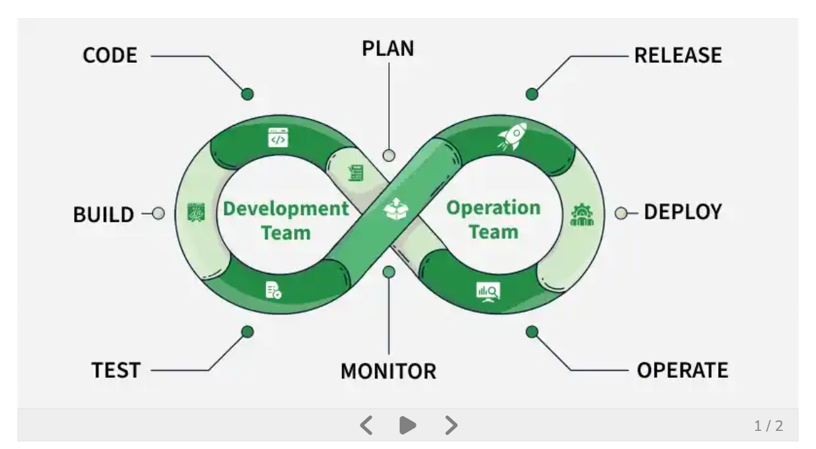

DevOps is a software development methodology that combines and automates the work of software development (Dev) and IT operations (Ops) to improve and shorten the systems development life cycle. It emphasizes collaboration between formerly siloed roles such as development, IT operations, quality engineering, and security. By adopting a DevOps culture, teams can better respond to customer needs, increase confidence in the applications they build, and achieve business goals faster.
One of the core practices in DevOps is Continuous Integration and Continuous Delivery (CI/CD). For continuos integration, instead of waiting until the end, they combine their work every day. They check whether everything still fits together. Developers combine their code frequently so problems are found early. Also, Small updates are safer than huge updates. This approach involves developers collaborating on a central code repository, where automated build processes are triggered to detect any code issues promptly. This leads to a quicker development cycle and a reduced error rate.
Traditionally:
- Developers write the code.
- Operations staff deploy and maintain the systems.
- Changes are handed over from one team to another, often causing delays and errors.
With DevOps:
- Both teams work together from the beginning.
- Testing and deployment are automated.
- Software updates are released more frequently and with fewer disruptions.
DevOps uses computers to automatically:
- Test software
- Install software
- Check security
- Create reports
- Watch systems
This reduces mistakes.
TOOLS DEVOPPS USE
GitHub
Stores code safely.
Jenkins
Automatically tests code.
Docker
Packages software neatly.
Kubernetes
Manages lots of software containers.
Azure DevOps
Microsoft's platform for planning, building, testing, and deploying software

DEVOPPS WORKFLOW
Step 1: Plan
- Business team requests the feature.
- Developers, Operations, and Security teams discuss requirements.
- Tasks are created.
Step 2: Develop
- Developers write the code.
- The code is saved in a shared repository such as GitHub or Azure DevOps.
Step 3: Test
- Automated tools test the new feature.
- Checks include:
  - Does the feature work?
  - Does it affect existing functions?
  - Are there security issues?
If tests fail:
- The code goes back to the developer for fixes.
If tests pass:
- Move to deployment.
Step 4: Deploy
- The new feature is automatically deployed to a test environment.
- After approval, it is deployed to the live application.
Step 5: Monitor
- Monitoring tools watch the application.
- The IT team checks:
  - Response times
  - Errors
  - Failed transactions
  - System availability
Step 6: Improve
- Customer feedback is collected.
- Bugs are fixed.
- New improvements are planned.
- The cycle starts again.
Real-Life Example
A customer loses an ATM card and wants to block it through the mobile app.
Using DevOps:
- Developers create a "Block Card" button.
- Automated tests verify it works.
- The feature is automatically deployed.
- Monitoring confirms customers can successfully block cards.
- Feedback is used to improve the feature further.
Why DevOps Helps
- Faster software releases
- Fewer mistakes
- Better security
- Happier customers
- Faster problem resolution
In simple terms, DevOps is a teamwork-and-automation process that helps companies continuously build, test, release, and improve software without causing disruptions to users.

CICD PIPELINE
CI/CD is an automated process that continuously integrates code changes, tests them, checks security, and safely delivers software to users, allowing organizations such as banks to release new features quickly and reliably.
Continuous Integration means developers frequently combine their code into a shared repository.
Before CI:
- Developer A writes code.
- Developer B writes code.
- Developer C writes code.
- After two months they try to combine everything.
- Many conflicts and bugs appear.
With CI:
- Developers merge small changes every day.
- Automated tests check that everything still works.

What is Continuous Delivery (CD)?
Continuous Delivery means software is always kept in a state where it can be released at any time.
After code passes all tests:
- It is packaged automatically.
- It is deployed to testing environments automatically.
- It is ready for production.
A human may still approve the final release.
Example
You build a new version of a banking app.
After passing all tests:
The app is prepared for release.
Security checks are completed.
Deployment files are created.
The app is ready for customers.
Someone simply clicks Approve.

What is Continuous Deployment?
Continuous Deployment goes one step further.
Instead of requiring a person to approve:
- The software is automatically released to customers once

What is a CI/CD Pipeline?
A CI/CD pipeline is the automated sequence of steps that code goes through from development to production.
Think of a pipeline as a conveyor belt.
Plain Text
Write Code
Build
Test
Security Check
Deploy
Monitor
Every time developers make changes, the pipeline runs automatically.
Fewer Errors
Computers perform testing consistently.
Humans forget things.
Automation reduces mistakes.
Better Security: Security scans happen automatically every time code changes.
Faster Recovery

Common CI/CD Tools
Git
Stores source code.
GitHub
Hosts code repositories.
Azure DevOps
Microsoft platform for planning, coding, testing, and deployment.
Jenkins
Automates builds and tests.
GitHub Actions
Automates workflows directly inside GitHub.
Docker
Packages applications consistently.
Kubernetes
Runs and manages applications at scale.

